## Multispecies model estimates of time-varying natural mortality in the GOA

*Grant Adams, Kirstin K. Holsman, Pete Hulson, Cole Monnahan, Kalei Shotwell, Ian J. Stewart4, and Andre Punt*

[adamsgd@uw.edu](mailto:adamsgd@uw.edu)

School of Aquatic and Fishery Sciences, University of Washington, Seattle, WA, USA

Resource Ecology and Fisheries Management Division, Alaska Fisheries Science Center, Seattle, WA, USA

Auke Bay Laboratories, Alaska Fisheries Science Center, Juneau, AK, USA

4International Pacific Halibut Commission, Seattle, WA, USA

## Summary statement:

The climate-enhanced multispecies model (CEATTLE) for the Gulf of Alaska (GOA) estimates that natural mortality for age-1 pollock and arrowtooth flounder due to all sources has declined in recent years and is below the long-term mean. Age-1 natural mortality for Pacific cod has increased in recent years, but remains below the long-term mean. Estimates of biomass consumed of pollock, Pacific cod, and arrowtooth flounder as prey across all ages is currently below the long term mean.

## Status and trends:

Estimated age-1 natural mortality (M) for walleye pollock, Pacific cod, and arrowtooth flounder peaked in 2005 for pollock, 2005 for Pacific cod, and 1991 for arrowtooth flounder (Fig. 1). Average age-1 M estimated by CEATTLE was greatest for pollock (1.25 yr) and lower for Pacific cod (0.84 yr) and arrowtooth (0.36 yr for females and 0.46 yr for males). After increasing slightly in recent years, pollock age-1 M still remained lower in 2023 at 1.09 yr (SD = 0.13) relative to the long-term mean 1.25 yr and the values used for single species assessment (age-1 M = 1.39; Fig. 1). Additionally, Pacific cod and arrowtooth flounder age-1 M were below the long-term mean, but above the values used/estimated for the single species assessment of 0.50 yr (Pacific cod), 0.2 yr (arrowtooth females), and 0.35 yr (arrowtooth males), with total age-1 M at around 0.78 yr (SD = 0.07) for Pacific cod, 0.35 yr (SD = 0.02) for arrowtooth females, and 0.45 yr (SD = 0.02) for arrowtooth males. 2023 age-1 M across species is 6.76% to 34.23% lower than in peak years.

On average 155,097 mt of age-1 pollock, 2,624 mt of age-1 Pacific cod, and 5,616 mt of age-1 arrowtooth flounder was consumed annually by species included in CEATTLE between 1977 and 2023. For 2023, we estimated 159,789 mt (SD = 18,404) of age-1 pollock, 2,337 mt (SD = 364) of age-1 Pacific cod, 4,345 mt (SD = 408) of age-1 arrowtooth females, and 2,337 mt (SD = 402) of age-1 arrowtooth males was consumed by species included in CEATTLE. Across all ages 561,929 mt of pollock, 27,411 mt of arrowtooth flounder, 5,483 mt of Pacific cod was consumed annually, on average, by species included in CEATTLE. The total biomass consumed of pollock and arrowtooth flounder as prey across all ages increased in 2023 compared to 2022 (Fig. 2). The total biomass consumed of Pacific cod has decreased in recent years. However, the total biomass consumed as prey across all ages for all species is currently below the long term mean.

## Factors influencing observed trends

Temporal patterns in total natural mortality reflect annually varying changes in predation mortality by pollock, Pacific cod, Pacific halibut, and arrowtooth flounder that primarily impact age-1 fish (but also impact older age classes). Predation mortality at age-1 for all species in the model was primarily driven by arrowtooth flounder (Fig. 3) and arrowtooth flounder biomass has declined in recent years. Increases in biomass consumed of walleye pollock in 2021 relative to 2020 reflect elevated recruitment of age-1 pollock in 2021 that was available to the modelled predators. Combined annual predation demand (annual ration) of age-4+ pollock, Pacific cod, and arrowtooth flounder in 2023 was 5.2 hundred thousand tons, down from the 6.73 hundred thousand ton annual average (Fig. 4).

## Implications:

We find evidence of continued decline in predation mortality on age-1 pollock and arrowtooth flounder due to the species modelled in CEATTLE. Previous ecosystem modelling efforts have estimated that mortality of pollock is primarily driven by Pacific cod (16%), Pacific halibut (23%) and arrowtooth flounder (33%)(Gaichas et al., 2015). Declines in total predator biomass are contributing to an overall decline in total consumption and therefore reduced predation mortality. Between 1990 and 2010, relatively high natural mortality rates reflect patterns in annual demand for prey from arrowtooth flounder, whose biomass peaked during this time period. A strong recruitment of age-1 pollock in 2021 has led to an increase in biomass of pollock being consumed by predators. Decreases in predation mortality in recent years suggest that the disappearance of the large age-1 recruitment of pollock in 2019 was not due wholly to predation by species included in the model.

## Description of index:

We report trends in age-1 natural mortality for walleye pollock (*Gadus chalcogrammus*), Pacific cod (*Gadus macrocephalus*) and arrowtooth flounder (*Atheresthes stomias*), from the Gulf of Alaska (USA). Total natural mortality rates are based on model estimated sex-specific, time- and age-invariant residual mortality (M1) and model estimates of time- and age-varying predation mortality (M2) produced from the multi-species statistical catch-at-age assessment model (known as CEATTLE; Climate-Enhanced, Age-based model with Temperature-specific Trophic Linkages and Energetics). The model is based, in part, on the parameterization and data used for recent stock assessment models of each species (see Adams et al., 2022 for more detail). The model is fit to data from five fisheries and seven surveys between 1977 and 2023 and includes inputs of abundance-at-age from recent stock assessment models for Pacific halibut scaled to the proportion of age-5+ biomass in IPHC management area 3 (Stewart & Hicks, 2021). Model estimates of predation mortality are empirically derived by bioenergetics-based consumption information and diet data from the GOA to inform predator-prey suitability (Holsman & Aydin, 2015; Holsman, Aydin, Sullivan, Hurst, & Kruse, 2019).

## Literature Cited

Adams, G. D., Holsman, K. K., Barbeaux, S. J., Dorn, M. W., Ianelli, J. N., Spies, I., Stewart, I. J., et al. 2022. An ensemble approach to understand predation mortality for groundfish in the Gulf of Alaska. Fisheries Research, 251: 106303.

Holsman, K. K., Ianelli, J., Aydin, K., Punt, A. E., and Moffitt, E. A. 2016. A comparison of fisheries biological reference points estimated from temperature-specific multi-species and single-species climate-enhanced stock assessment models. Deep Sea Research Part II: Topical Studies in Oceanography, 134: 360–378.

Holsman, KK and K Aydin. (2015). Comparative methods for evaluating climate change impacts on the foraging ecology of Alaskan groundfish. Mar Ecol Prog Ser 521:217-23510.3354/ meps11102

Holsman, K.K., Aydin, K., Sullivan, J., Hurst, T., Kruse, G.H., 2019. Climate effects and bottom-up controls on growth and size-at-age of Pacific halibut (Hippoglossus stenolepis) in Alaska (USA). Fisheries Oceanography, 28: 345–358. <doi:10.1111/fog.12416>

Gaichas, S., Aydin, K., and Francis, R. C. 2015. Wasp waist or beer belly? Modeling food web structure and energetic control in Alaskan marine ecosystems, with implications for fishing and environmental forcing. Progress in Oceanography, 138: 1–17. Elsevier Ltd. <http://dx.doi.org/10.1016/j.pocean.2015.09.010>.

Stewart, I., Hicks, A., 2019. Assessment of the Pacific halibut (*Hippoglossus stenolepis*) stock at the end of 2018. International Pacific Halibut Commission. Seattle, Wa, USA.

## Figures:

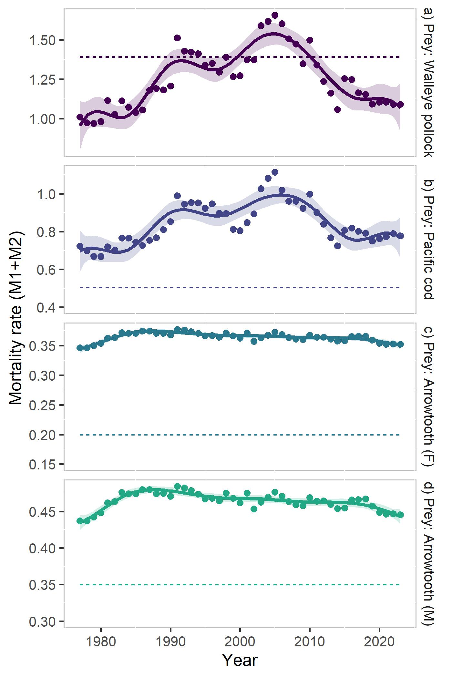

Annual variation in natural mortality (**M1+M2**) of age-1 pollock (a), Pacific cod (b), and arrowtooth flounder (females and males) (c/d) from the single-species models (dashed line), and the multi-species models with temperature (points; solid line is a loess polynomial smoother indicating trends over time)

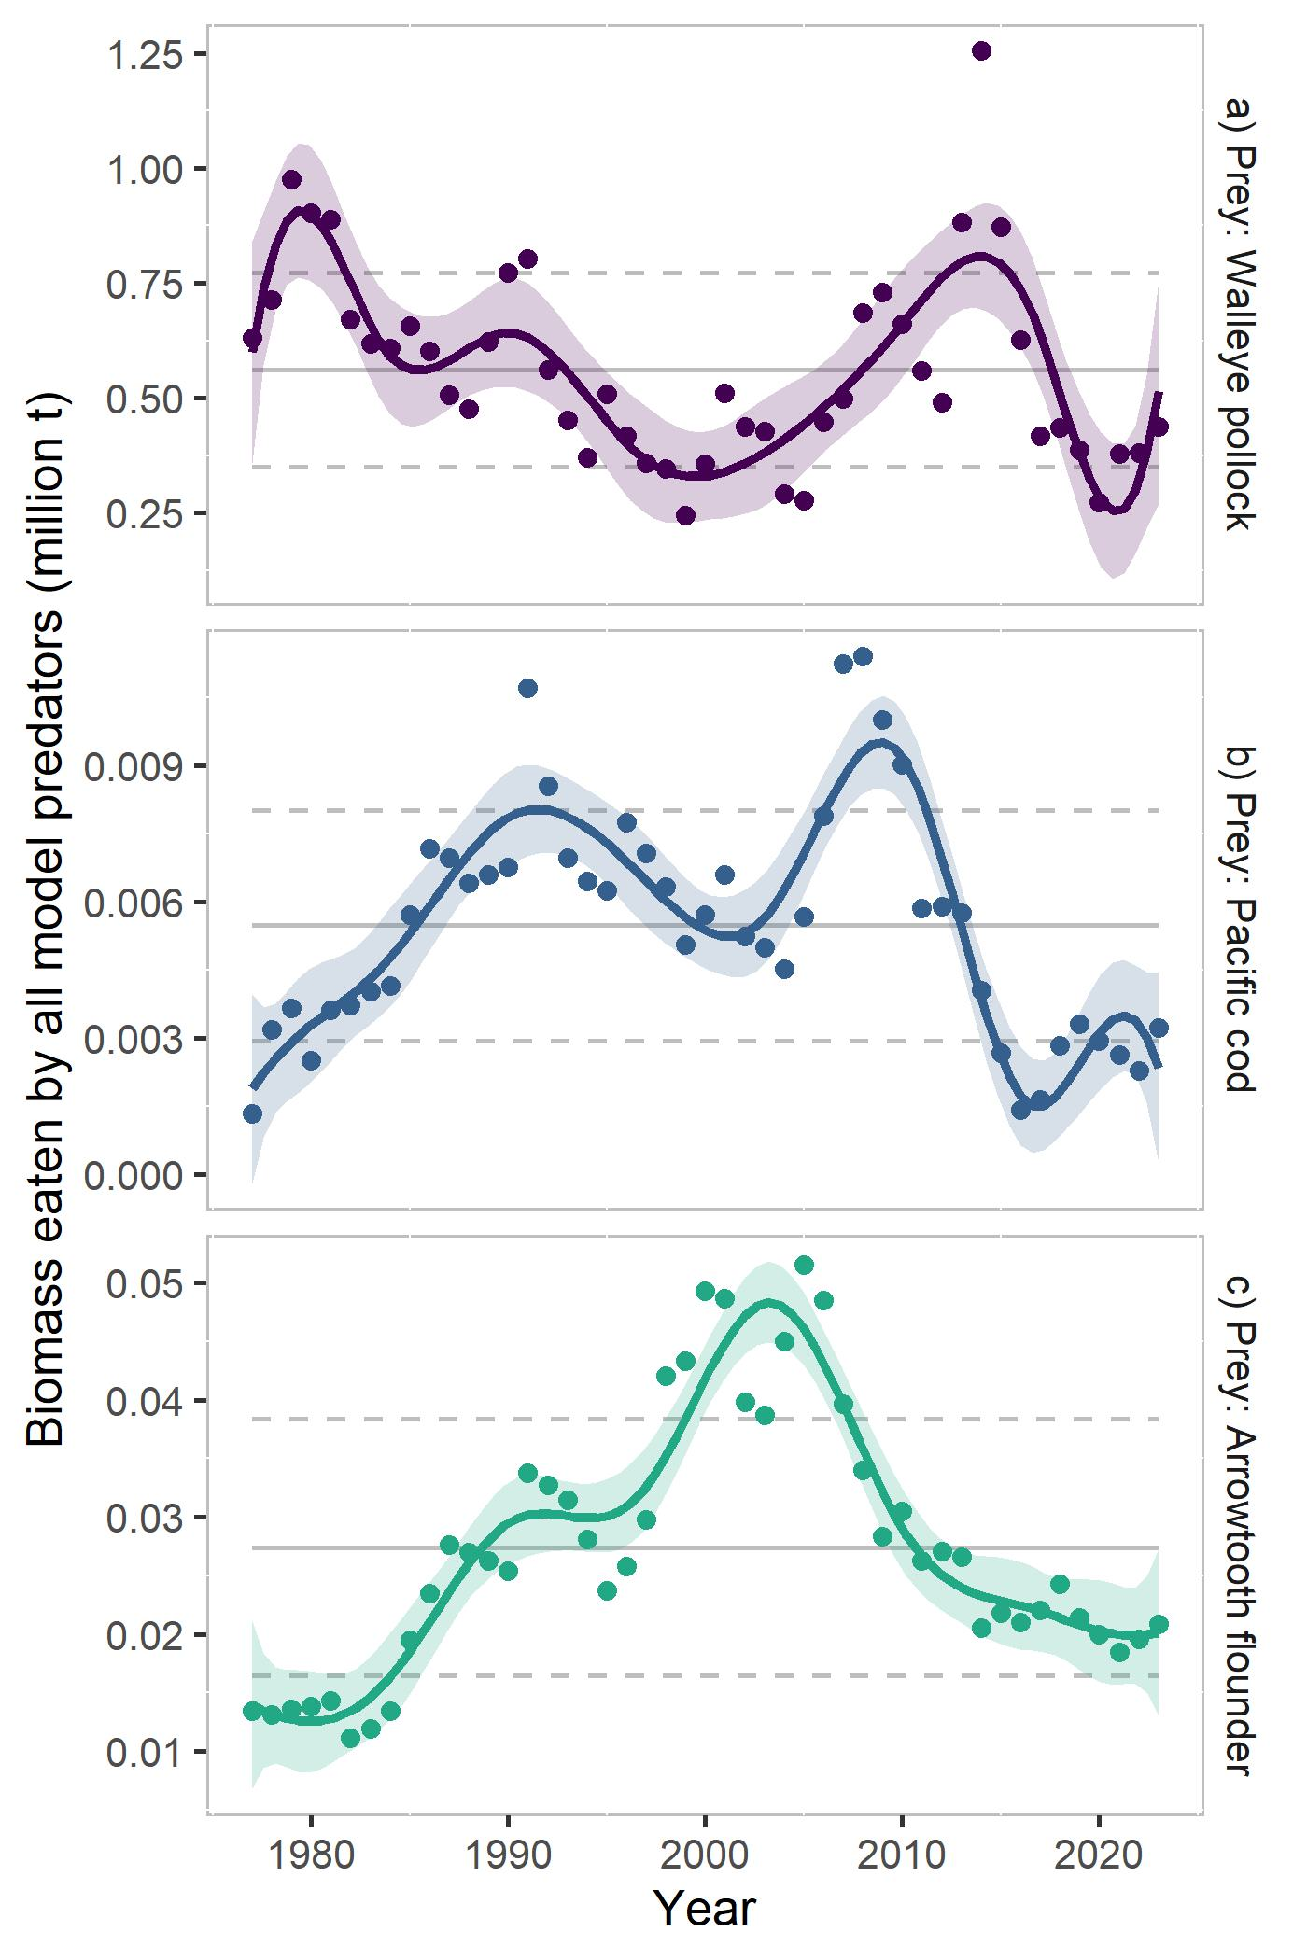

Multispecies estimates of biomass consumed as prey across all ages by all predators annually in the model of walleye pollock (a), Pacific cod (b), and arrowtooth flounder (c). Points represent annual estimates, gray lines indicate 1979-2023 mean estimates for each species, and the solid line is a 10 year (symmetric) loess polynomial smoother indicating trends over time.

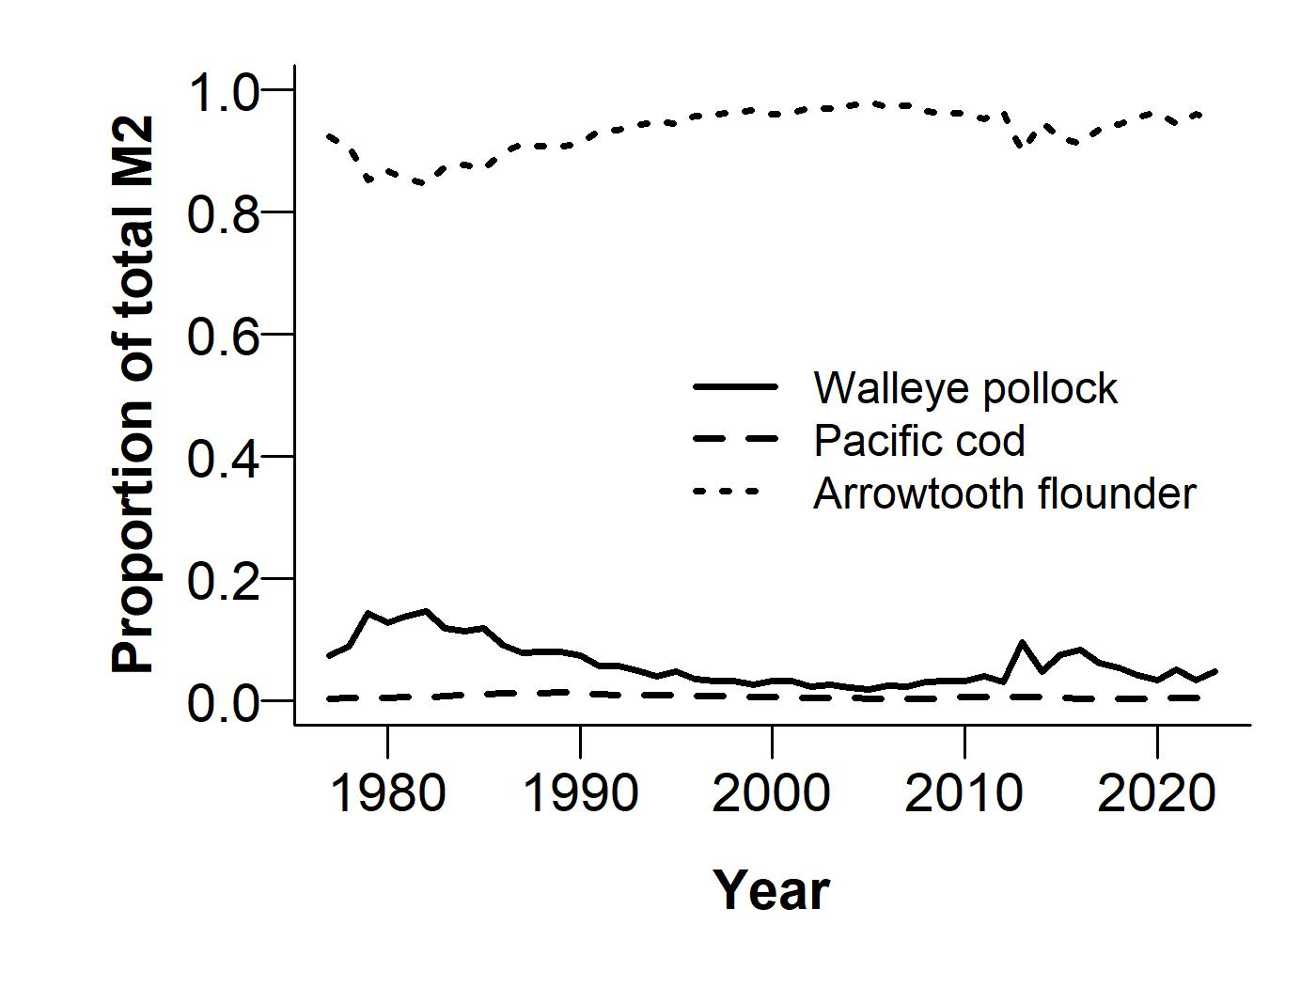

Proportion of total predation mortality for age-1 pollock from pollock (solid), Pacific cod (dashed), and arrowtooth flounder (dotted) predators across years. Updated from Adams et al. 2022.

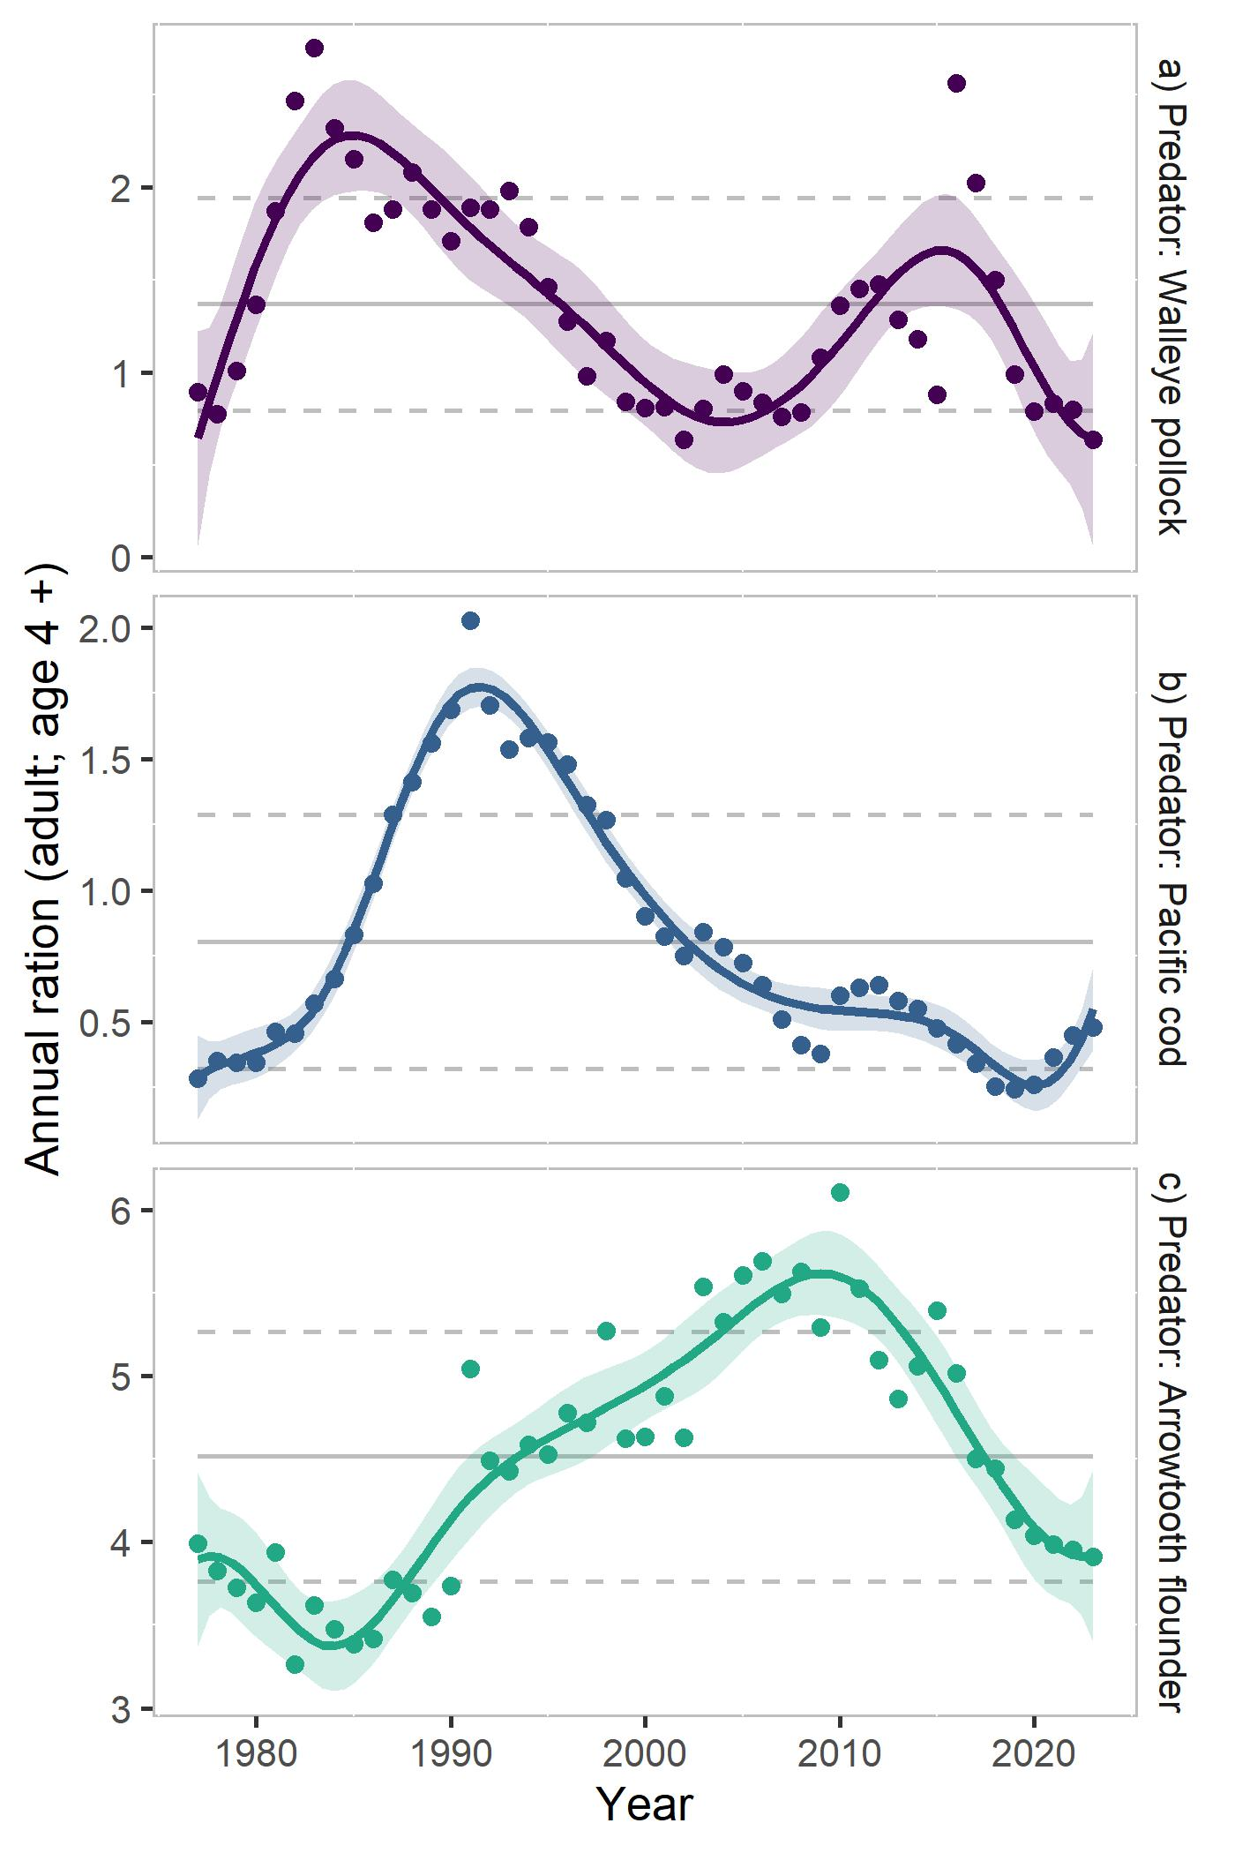

Multispecies estimates of annual ration (hundred thousand tons consumed per species per year) for adult (age 4 +) predators: pollock (a), Pacific cod (b), and arrowtooth flounder (c). Gray lines indicate 1979 -2023 mean estimates and 1 SD for each species; solid line is a 10 y (symmetric) loess polynomial smoother indicating trends in ration over time.